*History of Trade Liberalization in Morocco, and the present*

*Prior to 1996*

In the 1980s, Morocco faced a number of economic challenges including internal and external payment imbalances, unemployment and drought, prompting a series of economic adjustment programs. By 1993, the government adopted banking regulations and a privatization program to encourage foreign investments in Morocco. Changes in Morocco’s merchandise trade structure partly reflected its economic adjustment process: shares of imports in food and energy declined, whereas imports in raw materials, machinery and other capital goods increased. Morocco’s main exports were agricultural products, textiles, and phosphate; its service sector was largely driven by tourism. Nevertheless, Morocco’s earnings from remittances, exports of goods and services were not sufficient to cover the structural trade deficit (WTO, 1995).

Morocco acceded to the General Agreement on Tariffs and Trade (GATT) in 1987, participating actively in the Uruguay Round negotiations and hosting the Marrakesh Summit in April 1984. Morocco became an original member of the WTO in 1995 and completed the binding of all its tariff lines. Tariffs for agricultural products (live animals, meat, dairy products) were set at between 100 and 365 percent in 1993. Regarding services trade, Morocco adopted terms under the General Agreement on Trade in Services (1995), detailing market access conditions for certain categories of services (professional, business, value-added telecommunications, environmental, financial and tourism). As a member of the Arab Maghreb Union (AMU), Morocco enjoyed privileged access to Tunisia and Algeria. As a member of the Organization of the Islamic Conference, Morocco also concluded a number of bilateral trade and tariff agreements with several Arab and Sub-Saharan African countries (WTO, 1995).

Morocco’s trade policy in 1995 was a blend of progressive import liberalization and heavy agricultural protection. To protect domestic production, 10.2 percent of total merchandise imports to Morocco required licenses in 1994, in addition to import duties, the fiscal import levy (15 percent), and a parafiscal tax (0.25 percent). The maximum level of import tariff was initially lowered to 35 percent for most imports, but was raised later as a result of the introduction of certain tariff equivalents. Duties were especially high in the industrial and agricultural sector, especially for products that could have been produced in Morocco. On the export side, locally produced goods were promoted through tariff and tax concessions (WTO, 1995).

Due to frequent drought, the Moroccan government reoriented its agricultural policy in 1995 from self-sufficiency towards “guaranteed food security.” Agricultural production represented 40 percent of Moroccan labor force and its share of GDP declined from nearly 20 percent in the mid-80s to less than 15 percent in 1995. Under commitments of relevant WTO agreements, progressive liberalization of the agricultural sector was expected. Other aspects of the 1995 trade policy included diversification of industrial exports, revitalization of the motor vehicle sector, as well as expansion of the services and banking sectors (WTO, 1995).

*From 1996 to 2003*

In the years preceding and succeeding 2000, Morocco signed a number of bilateral trade agreements. Negotiations for a Morocco-EU Free Trade Agreement began in 1992. Prior to the talks, Morocco enjoyed free access to EU’s markets in industrial products, but EU’s agricultural protection policies restricted Moroccan exports in fruits and vegetables. The FTA was thought of as an important channel to improve Morocco’s access to EU markets. By some estimates, Morocco’s tariff reductions against the EU under the reciprocal FTA had the potential to provide additional trade liberalization benefits to Morocco, amounting to about 1.5% of GDP (Rutherford et al., 1997). The benefits would add up to 2.5% if Morocco added trade liberalization with the rest of the world to the free trade agreement; in this scenario, minimal trade diversion costs were offset by large trade creation effects (Rutherford et al., 1997). The Morocco-EU Free Trade Agreement officially entered into force in March, 2000. In addition, Morocco also signed the Agreement on the Global System of Trade Preferences (GSTP) among developing countries. A framework agreement on the Trade Preference System (TPS) among Islamic countries became effective in 2003 (WTO, 2003).

Morocco’s trade deficit continued into the early 2000s. By 2003, 62 percent of Moroccan imports were manufactures, mostly textile in connection to sub-contracting with partners in the EU. Other major import categories include agricultural and mining products. Morocco’s tariffication efforts in 1996 ended the imposition of quantitative import restrictions on the majority of products, and developments in the customs clearance procedure greatly enhanced the expediency and transparency of customs (WTO, 2003).

In 2000, Morocco incorporated the fiscal import levy into customs tariffs with the aim of simplifying imposition at the border, but this integration, coupled with the resulting rates from tariffication and the disaggregation of tariff lines, increased the simple average of tariff from 23.5 percent in 1995 to 33.4 percent in 2003. Imports were also subject to a number of other duties and taxes, including the parafiscal import tax of 0.25 percent, the value added tax up to 20 percent, and domestic consumption taxes (WTO, 2003).

In 2004, Morocco bound its tariff lines at ad valorem rates ranging from 0 to 380 percent; non-agricultural products were bound at 40 percent. Other duties and tariffs were bound at 7.5 or 15 percent. Over one-third of the tariff line were subject to rates higher than the bound rates, and variable duties charged on 40 agricultural products represented a deviation from Morocco’s commitments under WTO rules. In addition, Morocco introduced tariff quotas for certain agricultural products. In practice, however, these quotas were not applied: all relevant products were subject to the out-of-quota tariff, with the exception of fresh bananas which faced a safeguard duty of 130 percent (WTO, 2003).

Agriculture remained the most protected sector, a sector threatened by drought, limited modern production equipment, and high transportation costs. The government introduced a number of fiscal, customs and financial incentives to boost domestic agricultural production, also liberalizing prices of a large number of products. For the manufacturing sector, which experienced a slowdown in growth due to international competition, average duties in 2003 was 33 percent. The mining sector had the lowest tariff protection, averaging 22 percent (WTO, 2003).

In general, in the early 2000s Morocco actively participated in the multilateral trading system and in various regional and bilateral agreements, but it experienced difficulties meeting its commitments on binding and customs valuation due to protectionist policies, in particular related to agriculture. Custom tariffs were sometimes imposed at rates higher than the bound levels, in addition to variable duties. Moreover, mixed escalation of tariffs hindered certain domestic production activities, particularly semi-finished goods. The priorities for reform lay in liberalizing the agriculture sector, abolishing variable duties, and reducing the number and levels of tariff (WTO, 2003).

*From 2004 to 2009*

Morocco’s GDP per capita more than doubled from 2002 to 2009, from 1386 US dollars to 2861 dollars. The economy achieved growing diversification and benefited from strong internal demand and increased investment. The service sector, accounting for two thirds of GDP, remained the country’s largest driver of economic growth, followed by manufacturing, agriculture, and mining. Morocco concluded bilateral trade agreements with the United States and Turkey in 2004. The Arab-Mediterranean Free Trade Agreement between Morocco, Egypt, Jordan and Tunisia entered into force in 2007 (WTO, 2009).

Since 2003, Morocco had continued to engage in trade facilitation procedures. In January 2009, more than 90 percent of Moroccan imports go through customs with a computerized procedure. Customs duties were lowered such that the simple arithmetic average of duties fell by 13.2 percent since 2002 to 20.2 percent in 2009, particularly in the manufacturing sector (textiles and transport equipments). Similar to previous periods, variable duties and a generally high tariff applies to agricultural products (45.5 percent on average) and lower tariff apply to non-agricultural products (16.3 percent on average excluding petroleum) (WTO, 2009).

For a number of tariff line items (1373), the applied customs duty was higher than the bound duty. Although the number of tariff lines in the same situation was 5887 in 2002, this did not bide well for Morocco’s commitments to tariff bindings or WTO customs valuation rules. Moroccan policies for other duties and taxes (e.g. parafiscal import tax, value added tax) and tariff quotas facing agricultural products (which were not applied in reality because out-of-quota tariffs were lower than in-quota duties) remained the same since 2003. The government had taken steps to shorten the number of goods and services subject to price controls. Moreover, export taxes were abolished by 2008 (WTO, 2009).

Notable progress was observed in the tourism sector, which took over remittances as the main source of foreign exchange for Morocco. Under sectoral policy reforms, the telecommunications sector and banking services both expanded rapidly. The agricultural sector, while still the most protected sector in Morocco, benefited from public investment and numerous financial incentives (WTO, 2009).

*From 2010 to 2017*

After the 2008 financial crisis, Morocco’s international trade and investment environment were especially responsive to the reforms introduced. Between 2009 and 2014, goods exports grew more than 10 percent annually; goods imports grew even faster, widening Morocco’s trade deficit. On the other hand, service exports continued their dynamic growth, totaling 60 percent of Moroccan goods exports (WTO, 2016). As a result, Morocco’s current account balance declined from nearly 10 percent of GDP in 2012 to 4.8 percent in 2019.

Morocco and the EU reached a protocol on trade in agricultural products in 2012, yet Morocco still imposes many non-tariff barriers on its agricultural imports: threshold or minimum entry prices, seasonal restrictions depending on domestic production, and other forms of quotas. Since 2009, Morocco has continued efforts to facilitate the computerization of customs procedures, shortening the time during which goods remain in customs zones and ports. A framework agreement between customs and the tax authority also reduced the complexity of Morocco’s tax system facing imports (WTO, 2016).

Since 2009, Morocco undertook major reforms that caused the average MFN tariff to fall from 20.2 percent in 2009 to 10.5 percent in 2017. The trade weighted average rate for agricultural products decreased from 44.5 percent to 16 percent in 2017. Still, as signs of agricultural protection, over one-third of agricultural imports faced tariff above 25 percent, with animal and dairy products facing tariffs averaging 69.8 and 50.9 percent (WTO World Tariff Profiles 2019). A smaller number of agricultural imports now face variable duties compared to 2009. Average tariff for non-agricultural products declined from 16.3 percent to 9.1 percent in 2017 (WTO, 2016).

In 2008, the Government of Morocco launched the Plan Maroc Vert (Green Morocco Plan) for sustainable agricultural development. The objectives of the plan were to protect traditional production sectors from foreign competition and to promote local processing of imported inputs. Through the principle of tariff escalation, Morocco applied higher duties on agricultural product imports with higher levels of processing, thereby replacing imports of finished gods with domestic productions to narrow the trade deficit (WTO, 2016).

Ever since 2000, when Morocco combined the tariff and the fiscal import level, a number of tariff line items faced applied duties higher than the WTO bound rates. The number of such tariff lines declined from 1373 in 2009 to 792 in 2016 as a result of Morocco’s tariff reforms. Nevertheless, several other duties and taxes are still levied on imports, such as the parafiscal import tax, value added tax, and the “storage” tax for goods staying more than 3 days in customs (WTO, 2016).

In 2015, Morocco introduced a new legal framework governing trade defense measures, setting up the Import Monitoring Commission as the agency in charge. Since 2008, several new anti-dumping and safeguard duties have entered into force, some of them involving FTA partners, in the form of quotas above which additional duties apply. No countervailing investigations or measures have been enacted (WTO, 2016).

Through significant investments in transport, telecommunications and Internet infrastructure, Morocco’s economy and foreign trade continued to grow vigorously. The government’s current objectives are to continue opening up its economy to foreign trade, to promote sustainable investment (particularly in agriculture), and to develop rural areas through eco-tourism. In order to achieve these objectives, the WTO recommended further simplifying Morocco’s tax system and ensuring greater freedom of exchange (WTO, 2016).

The chart on the next page shows a graphic display of Morocco’s tariff with the rest of the world since data was first available in 1993. In 1993, the weighted average of Morocco’s MFN and AHS tariffs facing the rest of the world was 45.44 percent. Since Morocco’s entrance to the WTO in 1995 and the conclusion of a Morocco-EU Free Trade Agreement (FTA) in 2000, Morocco’s tariffs have continued to decline. In 2017, Morocco’s MFN weighted average tariff was 10.5 percent and effectively applied tariff averaged 3.8 percent.

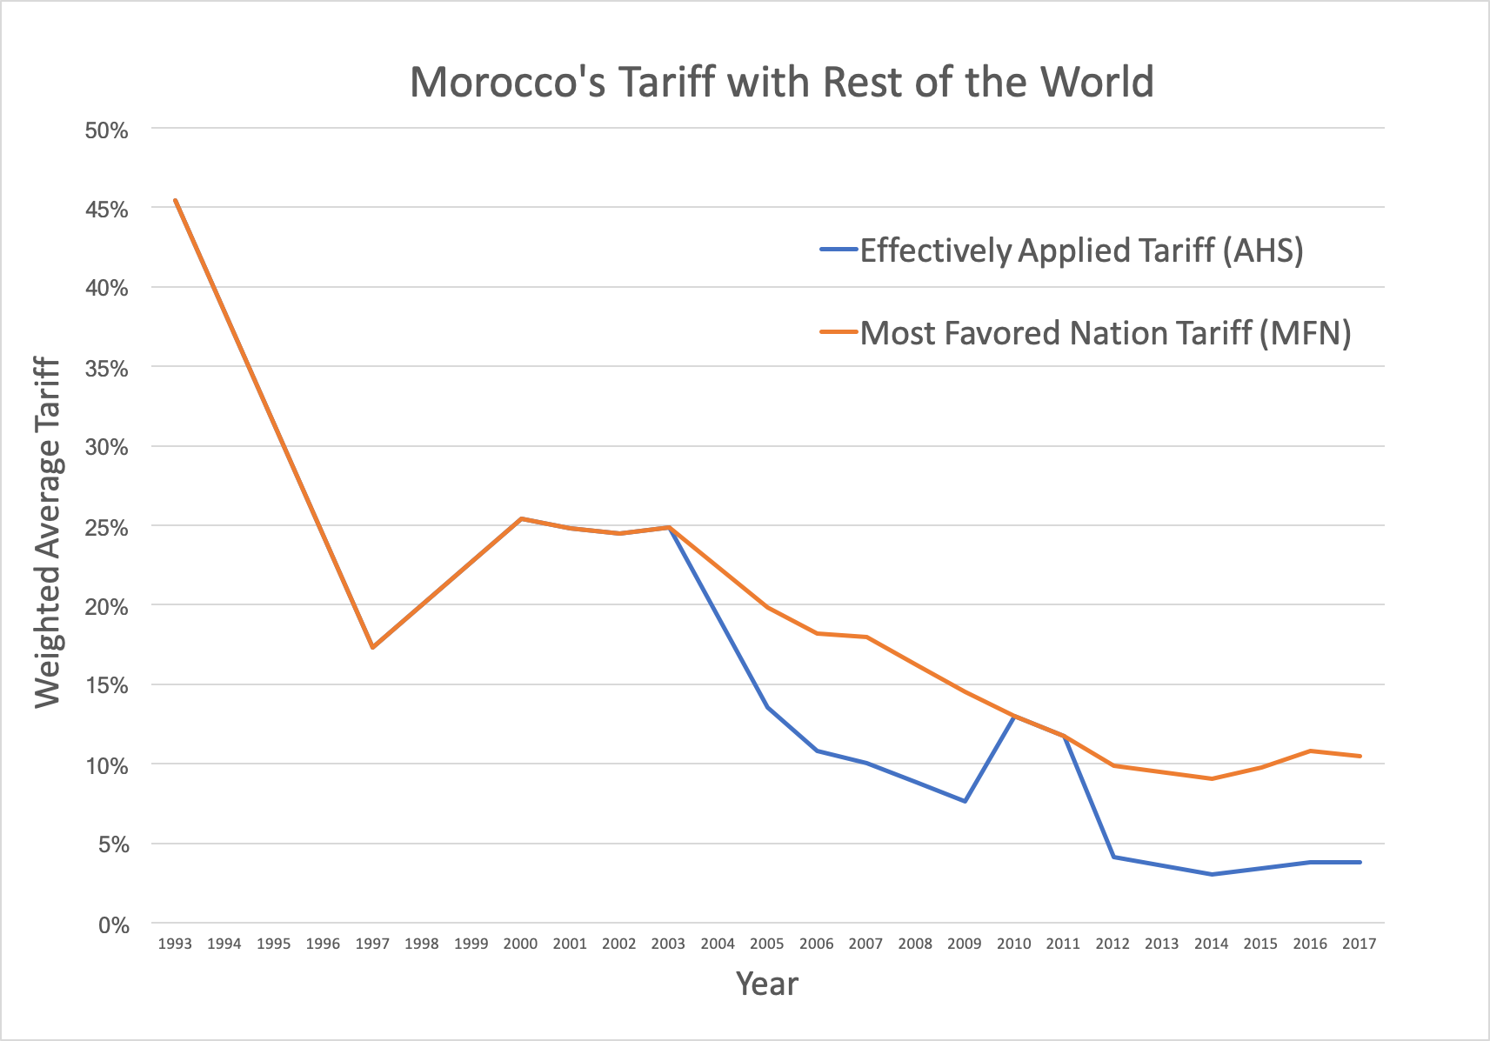

Morocco’s tariff facing the European Union, Morocco’s biggest trading partner, exhibits a similar trend (Appendix 1). In 2017, Morocco’s effectively applied tariff facing imports from the EU has a weighted average of only 1.31 percent. Effectively applied tariff for China, United States, and Turkey, respectively Morocco’s three biggest importers outside the EU, all declined substantially since the beginning of the millennium (Appendix 1). In 2017, Morocco’s biggest importers all face effectively applied tariff averaging below 1.5 percent; China is the only exception with an average effectively applied tariff of 8.89 percent, while accounting for 8.4 percent of Morocco’s imports.

Despite the positive progress in tariff liberalization observed in Figure 1, Morocco’s non-tariff measures (NTM) facing imports today are prevalent. Morocco’s imports have a 57.25 percent coverage ratio and 44.55 percent frequency ratio for non-tariff measures, respectively representing the share of values and the share of products in Moroccan imports affected by NTMs[1].

Sectoral-wise, 100 percent of agricultural product imports face non-tariff measures in the forms of sanitary measures and technical barriers to trade. A significant share of manufacture imports (70-93 percent) are subject to non-tariff measures, followed by industrial and raw material imports. Table 1 lists a summary of import categories most impacted by NTMs in Morocco.

| Table 1: Morocco Non-Tariff Measure by Sector | | | | |
| --- | --- | --- | --- | --- |
| Sector | NTM Coverage ratio | NTM Frequency ratio | NTM affected product - count | NTM affected trade |
| Animal | 100.00% | 100.00% | 204 | 709,941.18 |
| Hides and Skins | 100.00% | 100.00% | 59 | 277,027.05 |
| Vegetable | 100.00% | 100.00% | 317 | 3,894,712.11 |
| Fuels | 95.95% | 82.86% | 29 | 10,628,931.56 |
| Footwear | 93.12% | 57.45% | 27 | 228,037.29 |
| Minerals | 91.65% | 3.66% | 3 | 1,032,925.11 |
| Food Products | 80.38% | 97.98% | 194 | 1,379,392.55 |
| Textiles and Clothing | 69.11% | 65.07% | 503 | 2,714,552.44 |
| **All Import Products** | **57.25%** | **44.55%** | **2138** | **31,530,730.75** |
| Miscellaneous | 51.39% | 34.01% | 118 | 860,356.79 |
| Plastic or Rubber | 46.44% | 43.27% | 90 | 1,395,158.40 |
| Stone and Glass | 45.92% | 24.02% | 43 | 439,082.01 |
| Mach and Elec | 38.14% | 18.56% | 142 | 3,824,938.15 |
| Chemicals | 36.31% | 23.60% | 169 | 1,570,577.51 |
| Wood | 36.14% | 40.44% | 91 | 613,471.73 |
| Metals | 27.54% | 25.29% | 133 | 1,324,646.83 |
| Transportation | 11.37% | 13.56% | 16 | 636,980.05 |

Note: The coverage ratio is calculated by determining the value of imports of each commodity subject to NTMs. The frequency ratio indicates the percentage of traded products to which one or more NTMs are applied. NTM affected product - count represents the number of traded HS 6 digit products that are subject to one or more NTM measures. NTM affected trade measures sum of gross imports or gross exports that are affected by one or more NTM measures

Table 2 lists the top ten most imposed non-tariff measures in Morocco. Evidently, the most prominent NTBs are technical barriers to trade (Category B), pre-shipment inspection and other formalities (Category P), and charges, taxes, and other para-tariff measures (Category F).

| Table 2: Morocco Top ten most imposed non-tariff measures | | | | |
| --- | --- | --- | --- | --- |
| Measure | NTM Coverage Ratio | NTM Frequency Ratio | NTM affected product - Count | NTM affected Trade |
| Certification requirement (B830) | 36.56% | 33.36% | 1601 | 20,135,720.77 |
| Testing requirement (B820) | 31.09% | 22.71% | 1090 | 17,122,818.73 |
| Product quality or performance requirement (B700) | 30.98% | 25.44% | 1221 | 17,061,371.24 |
| Export taxes and charges (P500) | 27.18% | 16.27% | 589 | 8,514,873.46 |
| Inspection requirement (P610) | 19.84% | 17.59% | 637 | 6,214,527.55 |
| Excise taxes (F720) | 19.69% | 1.13% | 54 | 10,846,177.64 |
| Export technical measures, n.e.s. (P690) | 19.02% | 15.85% | 574 | 5,958,552.38 |
| Authorization requirement for TBT reasons (B140) | 14.99% | 2.75% | 132 | 8,253,825.54 |
| Labelling requirements (B310) | 11.82% | 15.46% | 742 | 6,510,171.70 |
| Packaging requirements (A330) | 10.55% | 13.84% | 664 | 5,808,300.56 |

*History of the Moroccan Current Account Deficit*

Over the course of 25 years since 1980, the Morocco economy managed to turn a current account deficit at 2 billion U.S. dollars into a surplus of the equivalent amount. In 1982, Morocco’s nearly 2-billion-dollar current account deficit represented over 10 percent of GDP, but the economy quickly recovered a current account surplus in 1988. The current account balance then fluctuated at around negative one percent of GDP until it rose sharply to a significant surplus at 4 percent of GDP in 2001, an event whose timing coincided with Morocco’s Free Trade Agreement with the European Union. According to the IMF Article IV Consultation for Morocco in 2001, this improvement in the external current account was a direct result of the April 2001 devaluation of the dirham. The current account has since deteriorated partly as a result of a real appreciation of the currency. During the financial crisis in 2008, Morocco’s current account balance witnessed the most significant decline in recent history, representing a drop at the magnitude of 5 percent of GDP. Graphic displays of Morocco’s current account balance history, measured in millions of 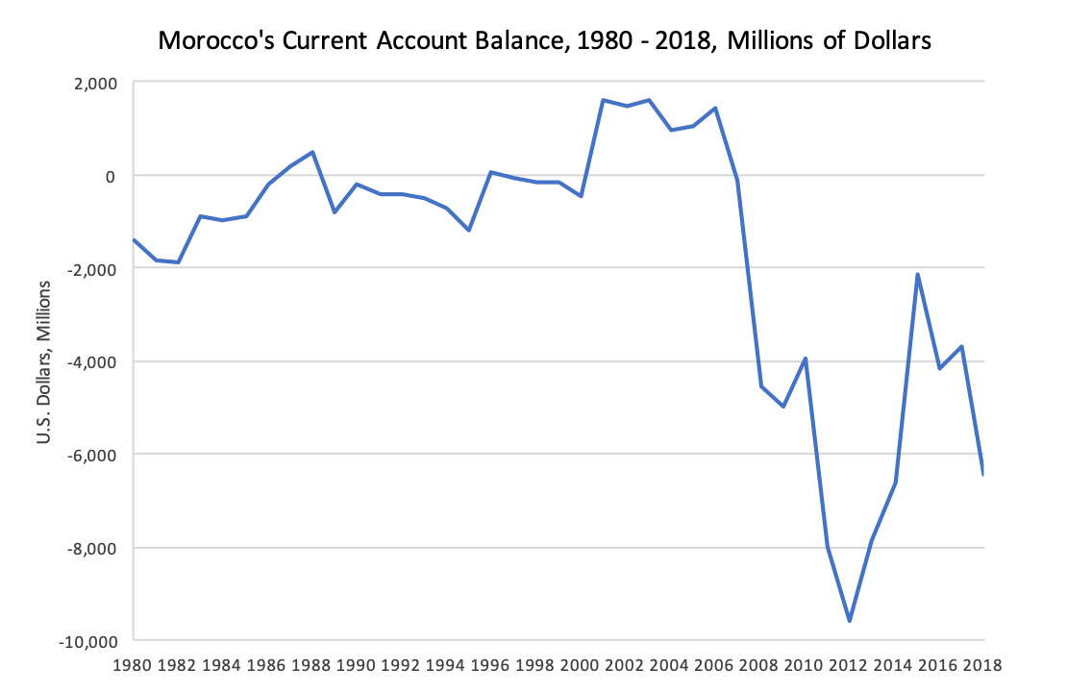dollars and as a percentage of GDP, are shown below.

|  |  |  |
| --- | --- | --- |
| Date | Value | Change |
| 2006 | 1,411 | 35.62% |
| 2007 | -122 | -108.65% |
| 2008 | -4,528 | 3610.76% |
| 2009 | -4,971 | 9.78% |
| 2010 | -3,925 | -21.04% |
| 2011 | -8,000 | 103.80% |
| 2012 | -9,571 | 19.65% |
| 2013 | -7,844 | -18.05% |
| 2014 | -6,597 | -15.89% |
| 2015 | -2,161 | -67.25% |
| 2016 | -4,180 | 93.44% |
| 2017 | -3,677 | -12.02% |
| 2018 | -6,445 | 75.26% |

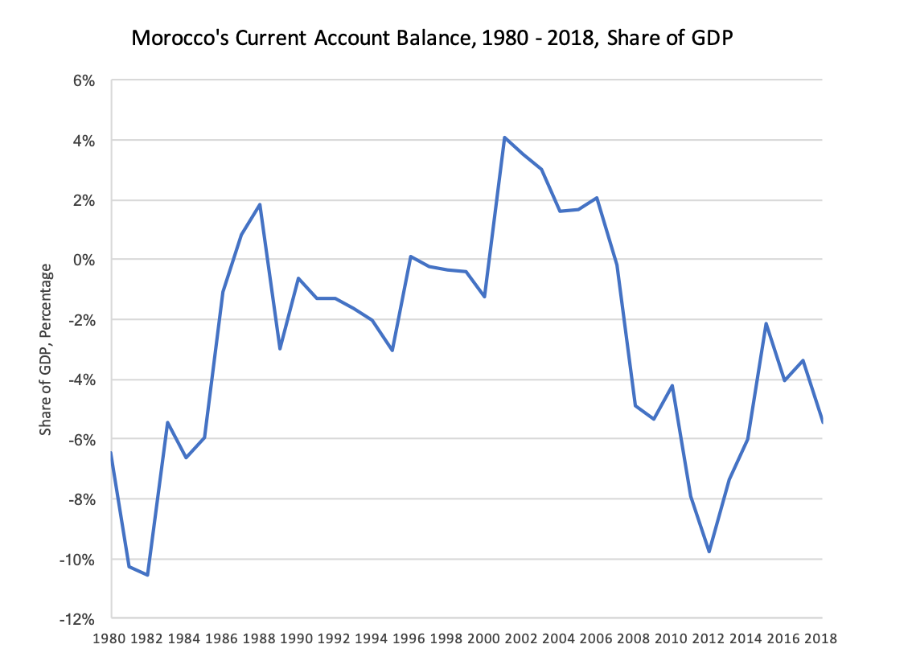

Although Morocco has consistently maintained a surplus in services trade, the goods trade balance deteriorated significantly after 2002 due to greater demands for merchandise imports originating from Morocco’s growing economy. The figure below shows Morocco’s goods trade balance, non-factor services trade balance, and remittances from Moroccans working abroad since 1980. Non-factor services comprise shipment, passenger, other transport services, travel, and miscellaneous transactions that are not attributable to the conventional factors of production (i.e. labor and capital). Evidently, remittances and services trade surplus were inadequate to fill the gap created by Morocco’s 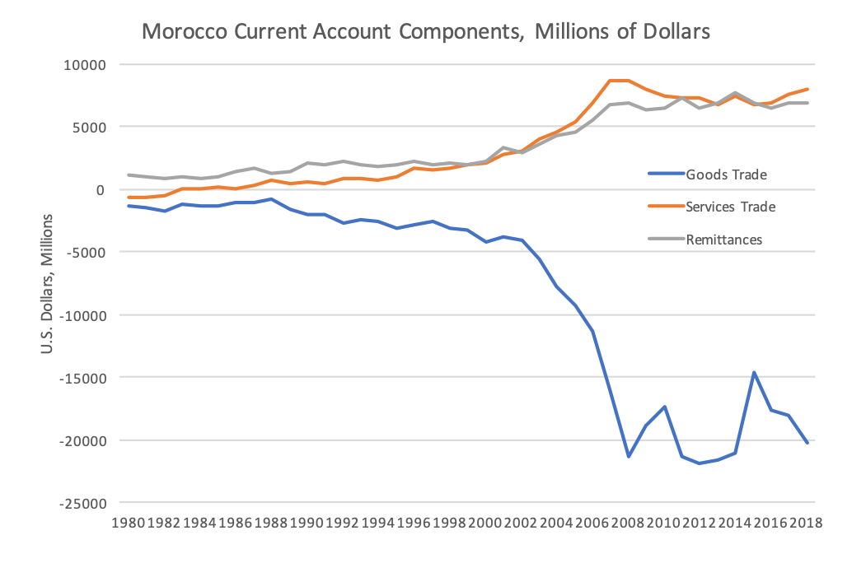large goods trade deficit, resulting in overall current account deficits since 2007.

Morocco’s reserve assets, mostly in the forms of convertible foreign currencies, have stayed at around 22 billion U.S. dollars since 2002. In years when Morocco experienced significant drops in current account balance, its foreign currency reserves also declined accordingly. A side-by-side comparison of Morocco’s annual reserve asset movements and current account balance since 1980 is presented 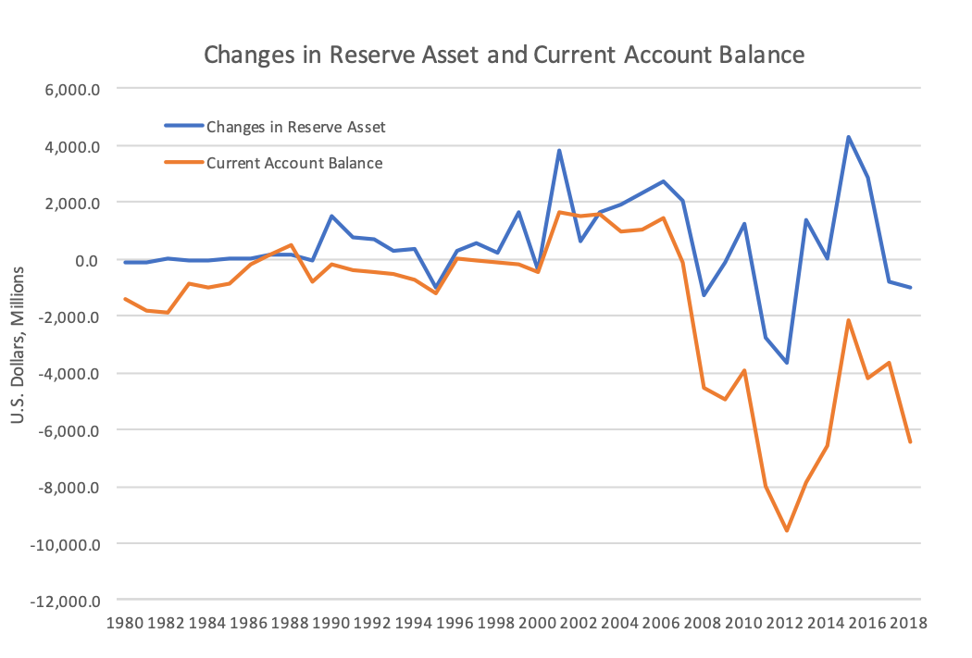below.

*Literature Review*

A majority of empirical literature identifies a negative relationship between trade liberalization and the trade balance. Studying 22 developing countries that had adopted trade liberalization policies since the 1970s (including Morocco), Santos-Paulino and Thirlwall (2004) identified empirical evidence that trade liberalization promotes import growth more than export growth, resulting in a deterioration of trade balance. Specifically, for a one percentage point reduction in duties, exports were found to grow under 0.2% while imports grow by between 0.2 and 0.4%. The natural explanation is that it is easier for importers to import than for exporters to reallocate resources to capture export markets. Using a panel data comprised of 42 countries, Parikh (2006) found that trade liberalization promotes growth in most cases, but the growth itself has a negative impact on the trade balance: countries following trade liberalization could have high real exchange rates, a worsening savings-investment balance and consequently a worsening current account balance. Santos‐Paulino (2004) estimated that the adverse effect on the trade balance to be around 2 percent of GDP, while the negative impact on current account balance is around 0.5 percent. Moreover, the impact of liberalization and other variables varies according to the region and type of trade policy regime existing, with Africa appears to have been more affected by the process of liberalization. El-Wassel (2012) examined data from 20 Arab countries over the period 1995-2010 and found that trade liberalization was detrimental to the trade balance when fuel exports were excluded from the equation. Khan and Zahler (1985) examined the effect of trade liberalization on the economies of Argentina, Chile and Uruguay and found that the volume of trade increased but the current account of the balance of payments went into severe deficit. The authors also found that capital flows generated by interest rate differentials were not sufficient to finance the deficits without adjustment. Ju et al. (2009) examined the relationship on a large sample of developing countries and found mixed evidence for such a negative impact.

Thirlwall and Gibson (1992) argued that the effect of trade liberalization on the trade balance is ambiguous from a theoretical perspective. In the partial equilibrium framework of the elasticity approach, the effect will depend on the extent to which import and export duties change and on the price elasticities of imports and exports. In the general equilibrium framework of the absorption approach to the balance of payments, the effect of liberalization will depend on how real income is affected relative to real absorption. In the monetary approach to the balance of payments, the outcome of liberalization depends on how the real demand for money changes relative to the real supply. Ostry and Rose (1992) similarly argued that there is no clear linkage between tariff liberalization and the trade balance.

On the other hand, factors other than trade liberalization may have contributed to Morocco’s current account trajectory. For instance, Krueger (1978) identified real exchange rate as a more important element than trade liberalization for promoting exports, which seemed to justify Morocco’s current account surplus after dirham’s depreciation in 2001.

*Conclusion*

Morocco made huge progress in trade liberalization; however, there are many areas where liberalization is less than what meets the eye. As a consequence of Morocco’s economic adjustment since the 1980s, Morocco’s import profile shifted from reliance on food and energy to raw materials, machinery, and other capital goods. Morocco joined the WTO as an original member in 1995 and quickly adopted measures to bind tariff lines and regulate services trade. In 2000, Morocco’s Free Trade Agreement with the European Union, its largest trading partner, entered into force, improving Morocco’s access to EU markets. By many estimates, the FTA had the potential to boost Morocco’s GDP by about 1.5 percent. Since then, Morocco has entered into an extensive list of bilateral or multilateral free trade agreements.

Morocco has continued to adopt trade facilitation procedures, including the computerization of the customs process. A 2009 framework agreement between Customs and the tax authority also reduced the complexity of Morocco’s tax system for imports. The period before the 2008 financial crisis saw rapid economic growth in Morocco, with the services sector being the largest driver of economic growth. The tourism sector, in particular, overtook remittances as the main source of foreign exchange for Morocco.

Although agriculture’s share of GDP has declined significantly over the last few decades (from 20 percent in the mid-80s to 12 percent in 2018), agriculture, accounting for nearly 40 percent of Moroccan labor force, remains Morocco’s most protected sector in terms of trade. The Government of Morocco imposes tariffs averaging 45.5 percent on agricultural imports until 2009, a figure that has since dropped to 16 percent by 2017. In addition, various value-added taxes are placed on 40 agricultural imports.

From 1993 to 2017, Morocco’s average MFN tariff fell from 45.44 percent to 10.5 percent. In 2017, Morocco’s effectively applied tariff averaged 3.8 percent with the rest of the world; average AHS tariff is below 1.5 percent for Morocco’s largest trading partners with the exception of China. In contrast, in 2017 the EU imposes a tariff averaging 5.1 percent for agricultural products from Morocco, and zero percent for non-agricultural products.

As a testament of Morocco’s potential for further trade liberalization, it is important to note that a large number of tariff line items (792 in 2016) still face applied customs duty higher than the bound duty, a direct violation of Morocco’s commitments under WTO rules. In addition to import duties, imports also face a parafiscal tax (0.25% of goods value) and domestic consumption taxes.

Non-tariff barriers to trade in Morocco are also prevalent. Morocco’s imports have a 57.25 percent coverage ratio and 44.55 percent frequency ratio for non-tariff measures. All agricultural imports to Morocco face some sort of non-tariff barriers, mostly in the forms of threshold or minimum entry prices, seasonal restrictions, or other forms of quotas. For all imports, the most commonly imposed non-tariff measures are technical barriers to trade, pre-shipment inspection and other formalities.

In 1982, Morocco’s current account deficit stood just below 2 billion dollars, over 10 percent of its GDP. Over the course of 25 years, the Moroccan economy turned the current account deficit into a surplus, highlighted by a 4 percent current account surplus in 2001 that was largely the result of a devaluation of the currency. Although Morocco had consistently maintained a surplus in services trade, the goods trade balance deteriorated significantly after 2002 due to growing domestic demand. Morocco’s earning from remittances, exports of goods and services were not sufficient to cover the structure trade deficit. The 2008 financial crisis sent Morocco’s current account balance into a significant deficit from which the external trade balance never recovered. Meanwhile, Morocco’s official reserve assets moved hand-in-hand with its current account balance.

In spite of progressive trade liberalization, Morocco’s current account deficit has persisted and threatened future growth of the economy. Morocco’s experience in this regard seems to echo the majority of findings in empirical literature, that imports tend to grow faster as a result of trade liberalization than exports. Despite theoretical ambiguity, existing literature and international experience affirms that trade liberalization policies have a direct causal relationship with deteriorations in current account balances.

References

El-Wassal, Kamal A. "The Impact of Trade Liberalization on Trade Balance in Arab Countries." *Journal of Economic & Social Research* 14, no. 2 (2012).

Krueger, Anne O. "Foreign Trade Regimes and Economic Development: Liberalization Attempts and Consequences Cambridge." *MA: Ballinger for NBER* (1978).

Ju, Jiandong, Yi Wu, and Li Zeng. "The impact of trade liberalization on the trade balance in developing countries." *IMF Staff Papers* 57, no. 2 (2010): 427-449.

Ostry, Jonathan D., and Andrew K. Rose. "An empirical evaluation of the macroeconomic effects of tarrifs." *Journal of international Money and Finance* 11, no. 1 (1992): 63-79.

Parikh, Ashok. "Relationship between trade liberalization, growth, and balance of payments in developing countries: An econometric study." *The International Trade Journal* 20, no. 4 (2006): 429-467.

Santos‐Paulino, Amelia U. "Trade liberalization and the balance of payments in selected developing countries." *The Manchester School* 72, no. 1 (2004): 100-118.

Santos‐Paulino, Amelia, and Anthony P. Thirlwall. "The impact of trade liberalization on exports, imports and the balance of payments of developing countries." *The Economic Journal* 114, no. 493 (2004): F50-F72.

Subasat, Turan. "Do liberal trade policies promote trade openness?" *International Review of Applied Economics* 22, no. 1 (2008): 45-61.

Thirlwall, A.P. and Gibson, G. *Balance of Payments Theory and the United Kingdom Experience*, London: Macmillan (1992).

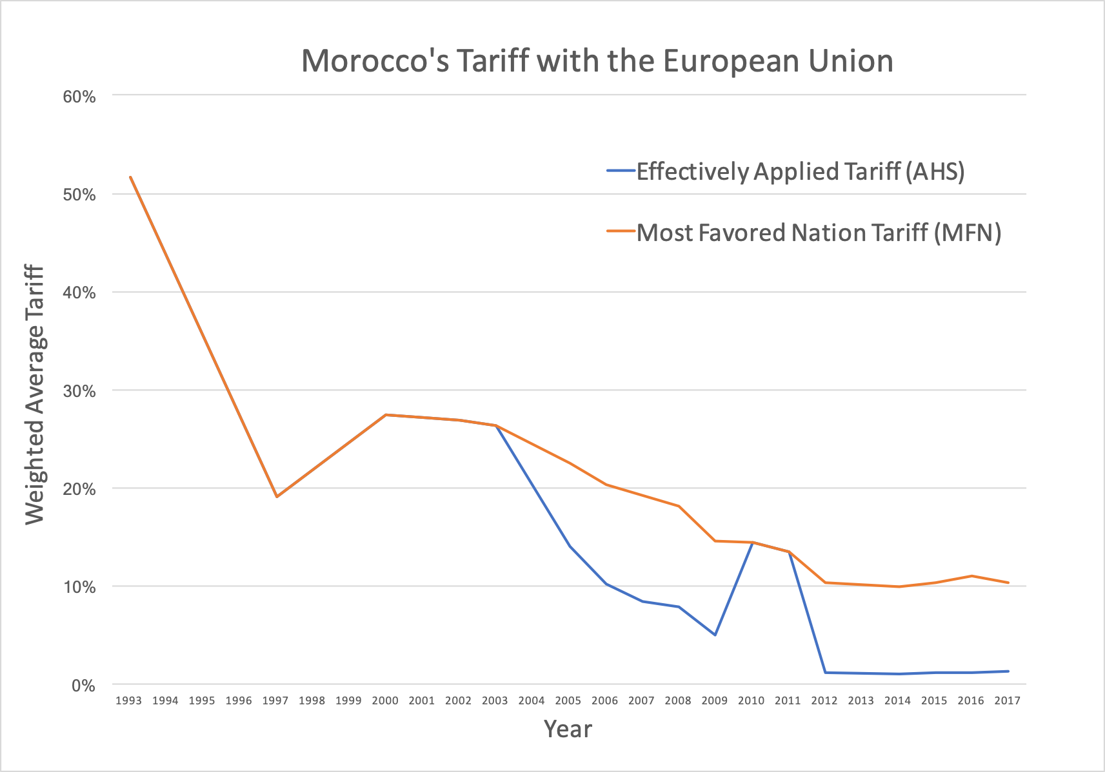Appendix 1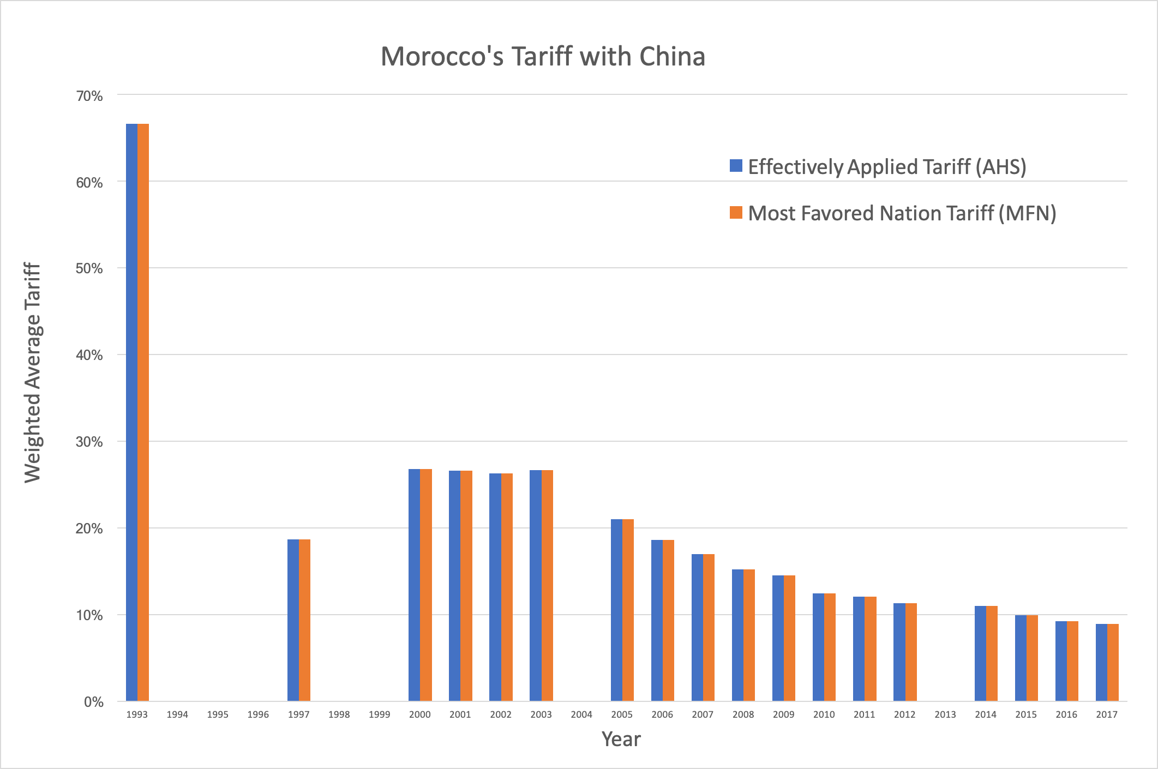

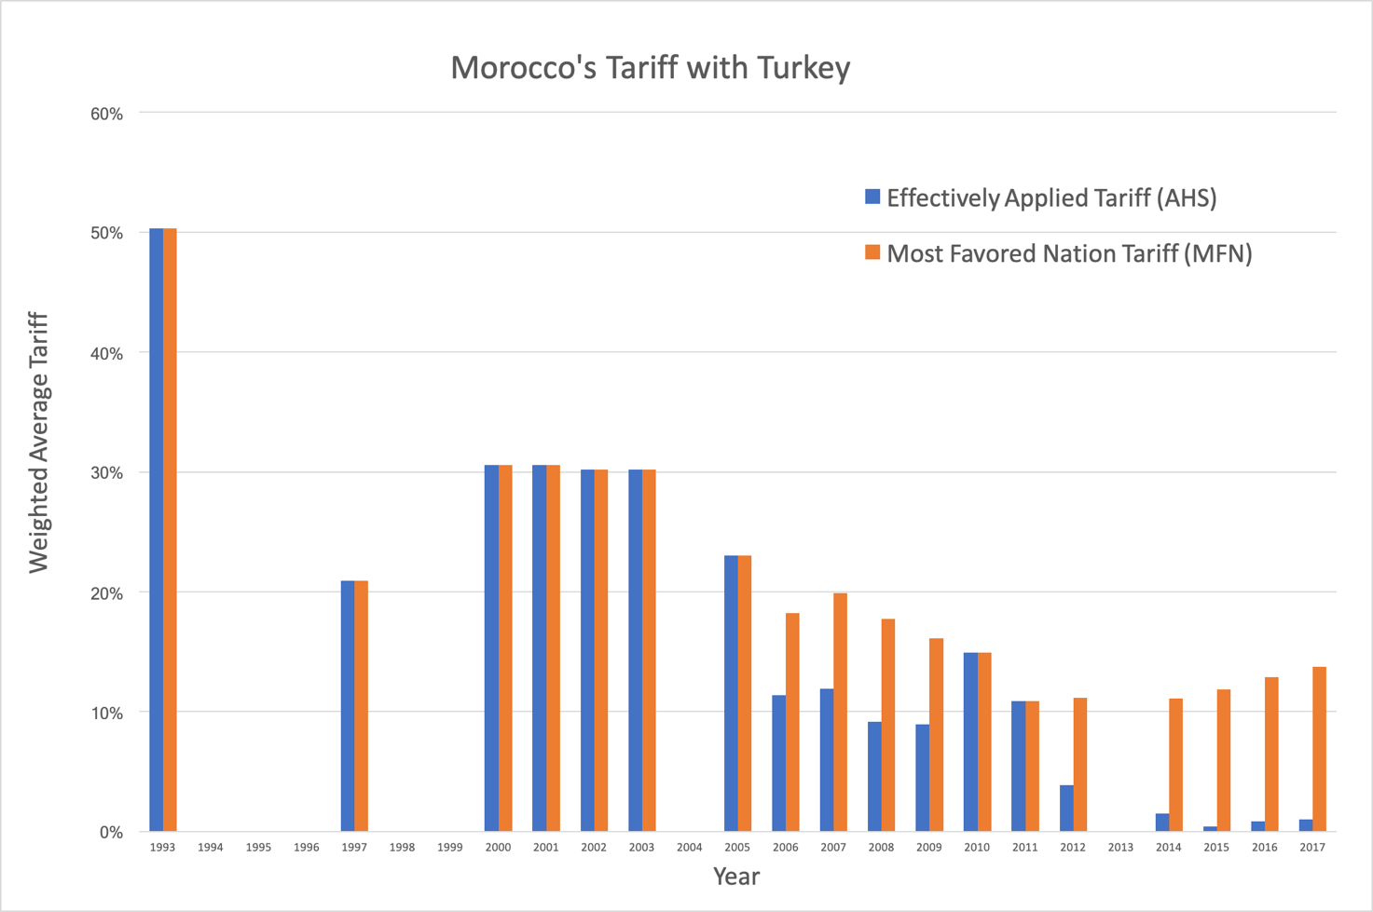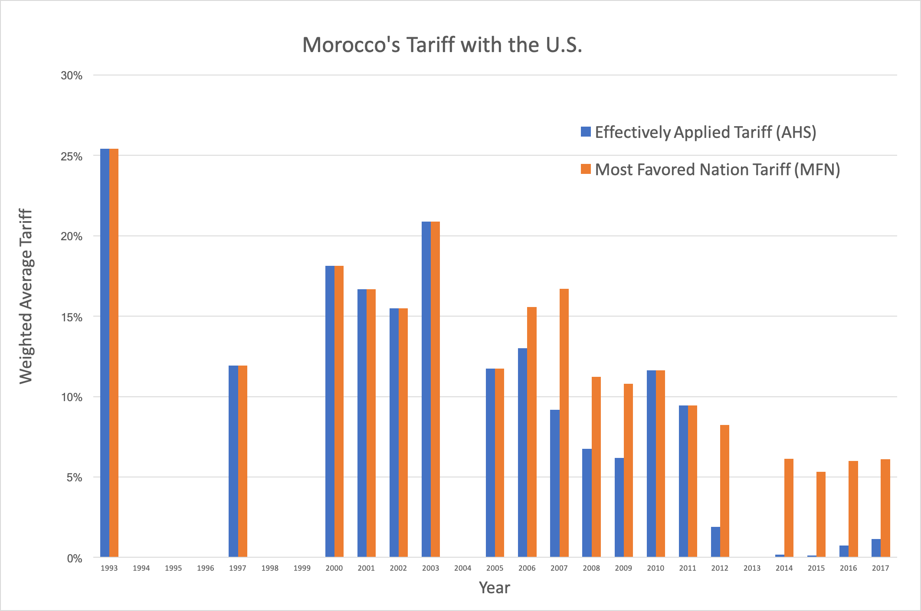

1. In contrast, the European Union have a coverage ratio of 94.31% and a frequency ratio of 93.88% for non-tariff measures.